- Цель работы
Создать в БД ХП, реализующие:
— вставку с пополнением справочников;
— удаление с очисткой справочников;
— вычисление и возврат значения агрегатной функции;
— формирование статистики во временной таблице;

Схема БД:
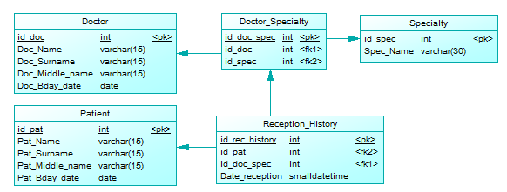
Вариант 14

- Наборы данных содержащихся в БД

Таблица Doctor
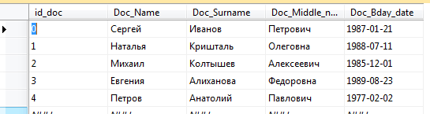
Таблица Patient
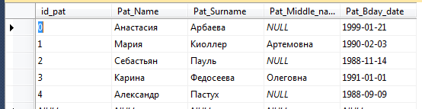

Таблица Specialty
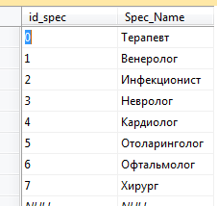
Таблица Doctor_Specialty
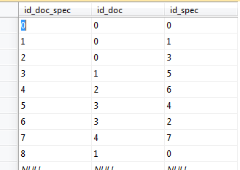
Таблица Reception-History
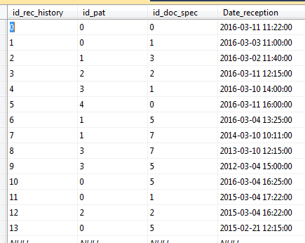

- Тексты ХП, запросов и их результатов

1) Процедура добавления специалиста;
Текст запроса:
create procedure Add_Specialist
@name varchar(15),
@surname varchar(15),
@middle_name varchar(15),
@bday date,
@specialty varchar(30)
as begin
declare @doc_id int
declare @new_doc_spec_id int
declare @id_spec int

set @new_doc_spec_id = (select max(id_doc_spec) from Doctor_Specialty) + 1
if @new_doc_spec_id is null
set @new_doc_spec_id = 0

set @id_spec = (select id_spec from Specialty where Spec_Name = @specialty)

if @id_spec is null
begin
set @id_spec = (select max(id_spec) from Specialty) + 1
if @id_spec is null
set @id_spec = 0

insert into Specialty values
(@id_spec, @specialty)
end

if @middle_name is null
set @doc_id = (
select id_doc
from Doctor
where
Doc_Name = @name and
Doc_Surname = @surname and
Doc_Middle_name is null and
Doc_Bday_date = @bday
)
else
set @doc_id = (
select id_doc
from Doctor
where
Doc_Name = @name and
Doc_Surname = @surname and
Doc_Middle_name = @middle_name and
Doc_Bday_date = @bday
)
if @doc_id is null
begin
set @doc_id = (select max(id_doc) from Doctor) + 1
if @doc_id is null
set @doc_id = 0

insert into Doctor values
(@doc_id, @name, @surname, @middle_name, @bday)
end

insert into Doctor_Specialty values
(@new_doc_spec_id, @doc_id, @id_spec)
end
go
exec Add_Specialist 'Test', 'Testov', null, '21.05.1922', 'Test'
go
2) Процедура удаления специалиста;
Текст запроса:
/* Процедура удаления специалиста */
create procedure Delete_Specialist
@name varchar(15),
@surname varchar(15),
@middle_name varchar(15),
@bday date
as begin
if @middle_name is null
delete Doctor
where
Doc_Name = @name and
Doc_Surname = @surname and
Doc_Middle_name is null and Doc_Bday_date = @bday
else
delete Doctor
where
Doc_Name = @name and
Doc_Surname = @surname and
Doc_Middle_name = @middle_name and Doc_Bday_date = @bday

create table #Useless_Spec (id_spec int primary key)
insert into #Useless_Spec
select id_spec from Specialty
except
select distinct Doctor_Specialty.id_spec
from Doctor, Doctor_Specialty
where Doctor.id_doc = Doctor_Specialty.id_doc

if exists (select * from #Useless_Spec)
delete Specialty where id_spec in (select #Useless_Spec.id_spec from #Useless_Spec)

drop table #Useless_Spec
end
go
/* ======================================================================== */
exec Delete_Specialist 'Test', 'Testov', null, '21.05.1922'
go
Результат:
(строк обработано: 1)
3) Количество пациентов принятых больницей за указанный год;
Текст запроса:
create procedure Get_Pat_Count @year int, @pat_count int = 0 out
as begin
select
@pat_count = Count(distinct id_pat)
from
Reception_History
where
Year(Reception_History.Date_reception) = @year
end
go
declare @x int
exec Get_Pat_Count 2010, @x out
select @x
Результат:
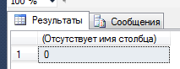
4) Количество пациентов принятых больницей за указанный год;
Текст запроса:
create procedure Get_Doc_Stats
@name varchar(15),
@surname varchar(15),
@middle_name varchar(15),
@bday date
as begin
declare @id int
declare @pat_count int
declare @avg_yaer_pat_cout int
declare @spec_count int

if @middle_name is null
set @id = (
select id_doc
from Doctor
where
Doc_Name = @name and
Doc_Surname = @surname and
Doc_Middle_name is null and
Doc_Bday_date = @bday
)
else
set @id = (
select id_doc
from Doctor
where
Doc_Name = @name and
Doc_Surname = @surname and
Doc_Middle_name = @middle_name and
Doc_Bday_date = @bday
)

if @id is null
return

create table #Doc_Stats (
name varchar(15),
surname varchar(15),
middle_name varchar(15),
bday date,
all_pat_count int,
spec_count int,
avg_year_pat_count int
)

set @pat_count = (
select Count(distinct id_pat)
from Doctor_Specialty, Reception_History
where
Doctor_Specialty.id_doc_spec = Reception_History.id_doc_spec and
Doctor_Specialty.id_doc = @id
)

set @spec_count = (
select Count(distinct id_spec)
from Doctor_Specialty
where
Doctor_Specialty.id_doc = @id
)
insert into #Doc_Stats values (
@name,
@surname,
@middle_name,
@bday,
@pat_count,
@spec_count,
(select Avg(pat_count)
from
(
select Count(distinct id_pat) as pat_count
from Doctor_Specialty, Reception_History
where
Doctor_Specialty.id_doc_spec = Reception_History.id_doc_spec and
Doctor_Specialty.id_doc = @id
group by
Year(Date_reception)
) as temp)
)
select * from #Doc_Stats
drop table #Doc_Stats
end
go
exec Get_Doc_Stats 'Сергей', 'Иванов', 'Петрович', '21.01.1987'
go
Результат:
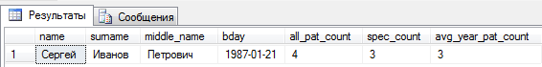
5) вывести среднее значение и статистику по годам
Текст запроса:
declare @x int
set @x = (
select Avg(pat_count)
from
(
select
Count(distinct id_pat) as pat_count
from
Reception_History as RH
group by
Year(RH.Date_reception)
) as C
)
select @x as avg_pat_count

select
Year(RH.Date_reception) as [year],
pat_count =
case
when Count(distinct id_pat) < @x then 'Меньше среднего'
when Count(distinct id_pat) = @x then 'Среднее значение'
when Count(distinct id_pat) > @x then 'Больше среднего'
end
from
Reception_History RH
group by
Year(RH.Date_reception)
go

Результат:
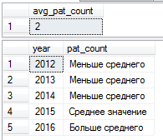
6) сформировать докторам зарплаты случайно, чтобы среднее значение было не меньше 15,000р.
Текст запроса:
create table #Doc_Salary (
id_doc int,
salary money
)

declare @doc_count int
select @doc_count = (select Count(id_doc) from Doctor)
select @doc_count as doc_count

while @doc_count <> 0
begin
set @doc_count = @doc_count - 1
insert into #Doc_Salary values
(@doc_count, cast(10000*rand() as money))
end

select Doc_Name, Doc_Surname, salary as Doc_Salary from Doctor, #Doc_Salary
where Doctor.id_doc = #Doc_Salary.id_doc

while (select avg(salary) from #Doc_Salary) < 15000
update #Doc_Salary
set salary = salary * 1.1

select Doc_Name, Doc_Surname, salary as Doc_Salary from Doctor, #Doc_Salary
where Doctor.id_doc = #Doc_Salary.id_doc

drop table #Doc_Salary
go
Результат:
